Sport Center Management Software

System-Wide Requirements Specification

# Introduction

This document suggested for specifying requirements and constraints in accordance with the FURPS+ classification.

# System-Wide Functional Requirements

The system’s use-case diagram is as below:

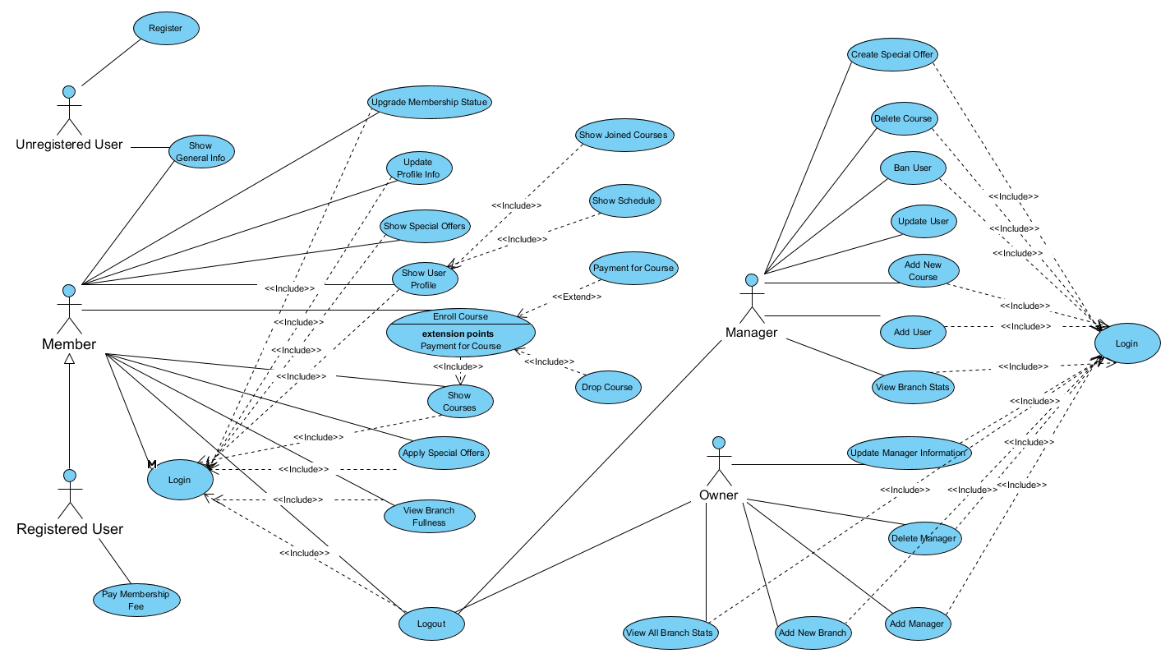

Use cases and their codes are given in the table below. Use cases tabular expressions in Appendix A. Also, if you want to get more detailed use case diagram, you can check Appendix D.

|  |  |  |
| --- | --- | --- |
| Use Case | Use Case Number | Use Case Code |
| Register | 01 | SCMS-UC-01 |
| Login | 02 | SCMS-UC-02 |
| Logout | 03 | SCMS-UC-03 |
| Pay Membership Fee | 04 | SCMS-UC-04 |
| Show User Profile | 05 | SCMS-UC-05 |
| Show Joined Courses | 05-02 | SCMS-UC-05-02 |
| Show User Schedule | 05-03 | SCMS-UC-05-03 |
| Show Nutrition Information | 05-04 | SCMS-UC-05-04 |
| View Branch Fullness | 06 | SCMS-UC-06 |
| Show Special Offer | 07 | SCMS-UC-07 |
| Apply Special Offer | 08 | SCMS-UC-08 |
| Show General Information About Sports Center | 09 | SCMS-UC-09 |
| Upgrade Membership Statue | 10 | SCMS-UC-10 |
| Show All Courses | 11 | SCMS-UC-11 |
| Show Course Information | 12 | SCMS-UC-12 |
| Enroll/Payment For Course | 13 | SCMS-UC-13 |
| Add New Course | 14 | SCMS-UC-14 |
| Delete Course | 15 | SCMS-UC-15 |
| Create Special Offer | 16 | SCMS-UC-16 |
| Ban User | 17 | SCMS-UC-17 |
| Add User | 18 | SCMS-UC-18 |
| Update User | 19 | SCMS-UC-19 |
| View Branch Stats | 20 | SCMS-UC-20 |
| Add New Branch | 21 | SCMS-UC-21 |
| View All Branch Stats | 22 | SCMS-UC-22 |
| Delete Manager | 23 | SCMS-UC-23 |
| Add Manager | 24 | SCMS-UC-24 |
| Update Manager Information | 25 | SCMS-UC-25 |

## Download mobile application

User can access android apk in website. The application should be free to download.

## User registration - Mobile/Web application

Given that a user has downloaded the mobile application, then the user should be able to register through the mobile application. System needs user information(name-surname), username, e-mail, password, branch info for registration.

## User log-in – Mobile/Web application

System takes and verifies the login information which are username and password with help of these fields filled by the user.

## Store user profile - Mobile/Web application

System holds all the data from users in the registration step and store them in database. Users can see that information from database on both of web and android application.

## Store training/nutrition information - Mobile/Web application

System open an activity division for all members and users can add their sport and nutrition activities to that division.

## Store member activities - Mobile/Web application

In the system’s database some entities such that reference, percent of attendance stores data with respect to user activities. These entities will be a reference for special offers or access right for other branches.

## Store employee and owner information - Mobile/Web application

System needs user information(name-surname), username, e-mail, password, branch info for registration. Like users, owner’s and employees’ must be registered to system too. Owners and managers can access the management panel via this information.

## Store information of all centers – Web application

In the system database, center’s information stored and with this information, system allows make changes in the management panel and shows visualization of the center.

## Management of branches – Web application

System create control mechanism with information of branches and managers can control the branch with management panel.

# System Qualities

## Usability

Android and web application has simple and compact design. Mostly used parts will appear on the more visible sides in design. Applications will have feedback system for processes user made. The visuality should stay remain in different screen sizes as well. Processes will be categorized with respect to user’s perspective.

## Reliability

Application should be avoided from crashes. The application should be reachable all the time. The information provided in the application, should be updated and correct. As like in the case of payment, the information transfer between the bank and the application should be safe and right. The users of the system will have secure access to applications.

## Performance

Effective usage of the system resources. Application should have short response time for any user processes. Applications provide multiple users to operate on the system. Applications can work concurrently. Data processes will take short time.

## Supportability

User can reach application from web and android platform. The visuality should be supported in a variety of screen sizes. Implementation will be understandable and readable for future improvements.

# System Interfaces

## User Interfaces

The interface should make easier the usage by displaying an organized and good-looking design.

### Look & Feel

The interface should be elaborate. It should not have an ordinary look with default styles and themes generated by Android Studio, but it should not be very complex neither. In this manner, we aim to make it simple but elegant.

In the website, we plan to use responsive design. In this way, our web site works on all screen sizes correctly. Besides that, we also use bootstrap 4 for implementing the material design. It helps us to provide a modern look.

### Layout and Navigation Requirements

Since there are lots of user operations, they should be categorized. The user should know the category that s/he might reach the operation needed, for this reason, the related categories to operations should be determined wisely. It is planned to design a menu for those categories.

In website design, we aim to minimum click to maximum performance. So, we design navbar and dropdown buttons with this methodology. Besides that, we don’t want to complex menu design. Therefore, we are working on adjusting weight between simplicity and usability.

### Consistency

The icons and titles that lead to a category from menu should be related to context and give the intuition of that context.

Since there are web and mobile applications in this system, the applications look similar and give the intuition to users that they are built for the same management system.

### User Personalization & Customization Requirements

We will make a general and default theme and style for mobile application for all users without allowing personalization. Other than this, the application should preserve the quality of view in various screen sized devices as well.

In website side, The Managers and Owners have management panel for managing the sport center. The members cannot access to this panel. Besides that, no difference between all types of members (Normal, Premium- Platin) in customization side and all users cannot personalize the own screens.

## Interfaces to External Systems or Devices

### Software Interfaces

The web and mobile applications are synchronized, and they use the same database.

As the external parts, system interacts with the bank and takes their verification for the payment. The software of the ID Card Reader in the center saves the entrance information, e.g. to classes, of the customer to our database system. It is assumed that the external parts are working correctly.

### Hardware Interfaces

Sports center uses a card reader system for entering to center and exiting from center. And when a member took a course and enter to the class, he/she has to show his/her id card to the card reader system again. Card reader system processes attendance information and stores in the database.

### Communications Interfaces

A communications interface is not available.

# Business Rules

**5.1 User Related Action Rules**

### Enter Another Branches Rule

Every member of the sports center can enter five times to other branches which user is not registered.

## Reward Rules

### Special Offer Rights Rule

Every member’s attendance stored in database for courses. With respect to the attendance percentage user may have rewards like discounts or one-month platinum membership. Branch’s manager will decide for special offer attendance percentage.

### Reference Rules

Every member’s reference number stored in database. If a member comes with his/her friend and take membership, reference number increases. With respect to this reference number member may have rewards.

## Manipulation Rules

### Add User

If there is a bug or unexpected situation happens in the system’s registration page, manager can add a user manually to the system. This feature is an advantage for if this software bought another company later, this company can add own users.

### Update User

Mail information of a user do not change by the user, manager can change user’s mail information.

### Ban User

If a member acts in inappropriate way, manager can ban user of that branch forever.

### Create Special Offer

Manager can create individual special offers for his/her branch. These special offers’ criteria will be attendance and reference number.

### Create a Course

Manager can create a course in his/her branch. Twenty-five percentage of the quota always keeping for platinum members. They can register a course above normal quota.

### Create New Branch

Owner of the company can open a new branch. Manager is assigned to a branch by the owner.

### Update Manager

Owner of the company has access for adding, deleting and updating manager management.

# System Constraints

* We will develop our application as both mobile and web application. Our mobile application will work on the android operating system.
* We will use the java spring framework for backend side and the Angular5 framework for the frontend side of the web application. Java programming language will be used for android application of the project.
* With help of primefaces interface library, we will choose design for web application.
* In the database management system of the project, we will use MySQL.

# System Compliance

## Licensing Requirements

The license requirements of the programs used during the development of the application, should be provided by client company. There is no license requirement that we apply to companies that purchase our application. Our application does not have any user restrictions. SportSupport don't provide the distribution of the application.

## Legal, Copyright, and Other Notices

SportSupport has no responsibility or guaranteed feature for this project. This project is for only educational purposes. Maintaining, licence and copyright belongs to the company which has bought to this project.

## Applicable Standards

In the development of the application will be used in English language. this increase the generalization and global availability of this application. So that, it will be easier to understand and develop the application in the future according to the company's request. The language of the application can be written as simple as possible, which will make the application easier to use.

# System Documentation

In project’s final release, there will be a manual to guide users. It gives some information of project’s running principles. Users can access this document in web and android application. Manual embedded in the web-application, users can download it to their computers or smartphone.

# Appendices

* SRS – Appendix A – Tabular Expressions of Use cases.
* SRS – Appendix B – GUI Prototypes
* SRS – Appendix C – Data Model with ER Diagram
* SRS – Appendix D – Big Use-Case Diagram